STEM Middle School Mini Lesson Template
STEM lessons will take a transdisciplinary approach. This template is designed to aid in the development of a transdisciplinary STEM lesson.
Title: Google Earth Tours, Unit : Stream Health
Grade Level: 6 to 8
Questions to ask before designing a lesson:
- What is the essential question(s) for the lesson?
How do humans contribute to stream health?
  - Why is the question relevant?
We live in Chesapeake Bay watershed and land is necessary for growing food.
  - What is the connection to real life?

We live in Chesapeake Bay watershed and land is necessary for growing food.
- What techniques are used to make the lesson:
  - Inquiry-based?
Stream-study research
  - Project-based?
Newspaper
- What are the lesson outcomes?
See lesson plan objectives
- How is participant discourse promoted?
Group work, creation of newspaper and Google Earth tour
- How are science, technology, engineering, and mathematics addressed in the lesson?
See lesson plan overview

Lesson #  Link | Lesson Title | Objective | Est. Time (min) | Maryland Standards
1  Go To 1 | - What contributes to stream health? | Students will be introduced to the focus question and determine what might be needed to complete the project. | 45-90 | Skills and Processes  -1.A.1.g, h  Science  - 7.6.A.1.a  -7.6.B.1.a, b
2  Go To 2 | - How do I use a GPS unit?  - What can I use a GPS for in real life? | Students will be introduced to the basic functions of a handheld GPS unit including how to mark and navigate to various locations. | 60-90 | Technology  -ITEA STL 11  -ITEA STL 3  -ITEA STL 13
3  Go To 3 | - How do I collect data at a stream?  - How do I conduct a stream study? | Students will preview data collection and stream analysis procedures through the use of iPod shuffle vodcasts.  Students will move to the field and conduct real life data and information collection. | 45-60  Fieldtrip | Skills and Processes  -1.A.1. b, g  Technology  -ITEA STL 8  -ITEA STL 11  -ITEA STL 17  Math  -7.4.B.1.a,b,c  ELA  -4.A.1.b  -4.A.1.a,c,f  -2.1.a, c  S.S.  -6.A.3  -6.B.1.b
4  Go To 4 | - How can I display my information to an audience?  - How do you write a newspaper? | Students will explore different presentation tools available for distribution of information.  Students will utilize Microsoft Publisher to collaborate on a student generated newspaper for distribution of field information gathered from field trip. | 45-90  90-120 | Skills and Processes  -1.B.1.a, d  -1.C.1.a, b,  Technology  -ITEA STL 9  ELA  -4.A.1.b  -4.A.1.a,c,f  -2.1.a, c

5  Go To 5 |  | - How can I track locations on Google Earth?  - What is the real world application of uploading points and pictures onto Google Earth? |  | Students will learn how to upload points from their GPS units directly into Google Earth, as well as add place markers, pictures, hyperlinks, etc.  Students will analyze the applications of Google Earth to other real world problems and ideas | 60 -120  60-90 |  | Science  -6.6.A.1.c  -6.6.B.1.c  Technology  -ITEA STL 10
6  Go To 6 | - What is a watershed?  - What watershed do I live in? |  | Students will explore different websites to determine what a watershed is and prepare for future field trip  Students will research which small and large watershed they reside in through the utilization of websites |  |  | 45 |  | Science  -7.6.A.1.a  -7.6.B.1.a,b  Technology  -ITEA STL 5  -ITEA STL 3
7  Go To 7 | - Field Study to collect points and identify macro invertebrates at Bush Creek |  | Students will travel to Bush Creek to collect GPS location points and identify the macro invertebrates in Bush Creek. This field trip is organized by the Bridging the Watershed organization. |  |  | Fieldtrip
8  Go To 8 | - Uploading points to Google Earth  - Creating a virtual tour in Google Earth |  | Students will upload their points from Bush Creek to Google Earth  Students will use previous knowledge of marking points, uploading pictures, and hyperlinks to create a virtual tour in Google earth |  |  | 45  90-120 |  | Skills and Processes  -1.B.1.d  -1.C.1.a,b,d,e  Technology  -ITEA STL 3
9  Go To 9 | - Identify similarities and differences between different water locations and stream health |  | Students will use Google Earth to explore the surroundings around the 2 different field trip locations to analyze their findings of stream health. |  |  | 90-120 |  | Science  - 7.6.A.1.a  -7.6.B.1.a,b  Technology  -ITEA STL 3
10  Go To 10 | - Continue fall and spring fieldtrip comparison/contrast evaluation |  | Continue analysis of Fall and Spring trips |  |  | XXX

Date | How do humans affect plant and animals around a water source?
Lesson 1  (Multiple Day) | Objectives:  How do you know if animals are living in a water area? | ECC:  Skills and Processes  -1.A.1.g, h  Science  - 7.6.A.1.a  -7.6.B.1.a, b | HOQ:  How can you determine if a water source is healthy?
Resources/Materials | Computers/internet  Student jump drives  www.glogster.edu  www.prezi.com  Google Earth
Stream Health Resources | http://www.streamhealth.maryland.gov/  http://www.eco-check.org/reportcard/chesapeake/2010/streamhealth/  http://www.waterencyclopedia.com/St-Ts/Stream-Health-Assessing.html  http://www.fmr.org/projects/shep
Warm-Up | Compile a list that might be evidence of animals at a water source.
Activities/Lesson | Day 1  - Once the students have completed their warm-up discuss as a class  - Create a class T-Chart of positive evidence and negative evidence  - Ask why it is important to know positive and negative evidence  - After the class creates a class chart, the students will research if their evidence is true or myth  - Present findings in an electronic format: glogster, powerpoint, prezi  - Students have 2-3 minutes to present their findings  Day 2  - Once the students have presented on their findings, use Google Earth to scour out different local water sources in the area  - Looking on Google Earth, make a prediction on stream health based on location  - Provide evidence to support your prediction  - Example: I believe Bush Creek is a healthy water source because there are no parking lots or building around and only farm land directly next to it.
Assessment | - Student presentations for stream health indicators  - Students need to provide 3 indicators  - Google Earth local stream locations  - Students should locate at least 2 streams in the local area  - Prediction of stream health with evidence statement
Homework | None

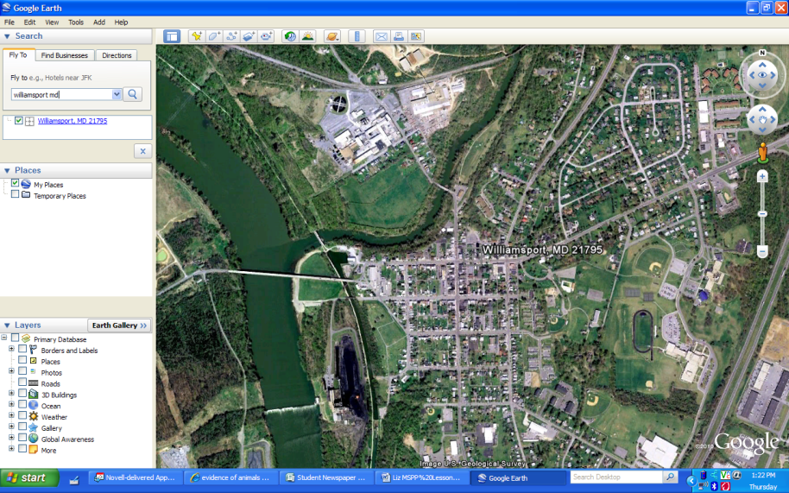
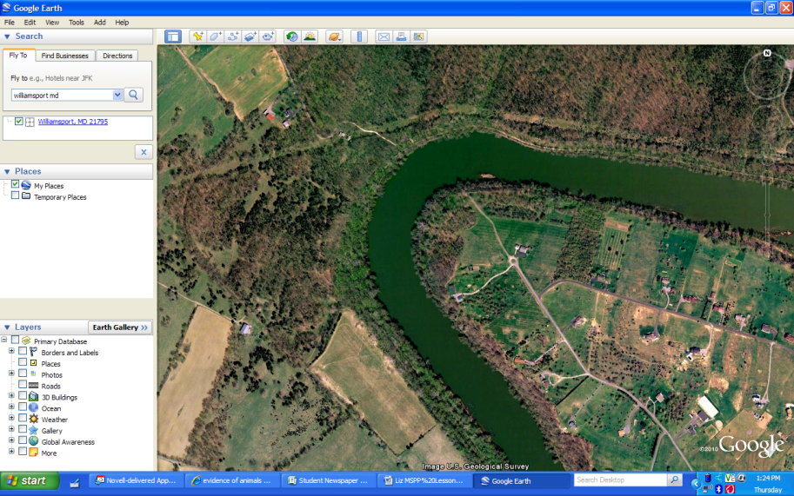
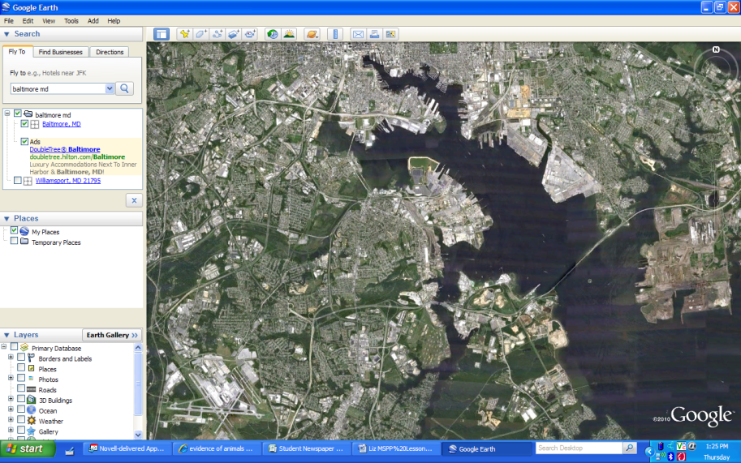

Date | How do humans affect plant and animals around a water source?
Lesson 2  (Multiple day – to be determined by student speed) | Objectives:  How do I use a GPS?  What can I use a GPS for in real life? | ECC:  Technology  -ITEA STL 11  -ITEA STL 3  -ITEA STL 13 | HOQ:
Resources/Materials | GPS units  Predetermine locations outside  Document camera  Flip Cameras/Video Cameras  GPS Manual
Additional Technology Resources | Any video converter (AVC) free file converter download  Windows Movie Maker (wma files)
Warm-Up | What does GPS stand for?  What is GPS used for in real life?
Activities/Lesson | - Review the warm-up questions and answers  - Show the students how to use the GPS units  - Utilize the document camera to show the different buttons to the students as a group  - Have the students walk through the different screens with presenter  - Once the students are comfortable with the different GPS screens, give the students the predetermined coordinates  - At each coordinate have a different piece of evidence to collect at each location (as a safeguard to ensure the students visit each location)  - Students will go around and collect all pieces of evidence  - After the students have located their points students will generate a ‘how-to’ video on using a GPS and plotting points.
Assessment | - Student responses to the warm-up question  - Location/Gathering evidence at each GPS location  - Student generated how-to-videos
Homework | None

Date | How do humans affect plant and animals around a water source?
Lesson 3  (Multiple day) | Objectives:  How do I collect data at a stream?  How do I conduct a stream study? | ECC:  Skills and Processes  -1.A.1. b, g  Technology  -ITEA STL 8  -ITEA STL 11  -ITEA STL 17  Math  -7.4.B.1.a,b,c  ELA  -4.A.1.b  -4.A.1.a,c,f  -2.1.a, c  S.S.  -6.A.3  -6.B.1.b | HOQ:  How can you determine if a water source is healthy?
Resources/Materials | iPods with podcasts/vodcasts preloaded  materials for stream study  turbidity  flow rate  macroinvertrates  nitrates  pH  dissolved oxygen  temperature
Examples | Student Generated Newspaper  Stream Study Note Sheet  Graphs
Warm-Up | Write down ideas of how you can record data collected. Is there one way or many?
Activities/Lesson | Day 1  - Discuss with the students their answers to the warm-up question  - If students talk about data charts – ask for what purposes would they use that for?  - If students talk about graphs – ask them what types of graphs and for what purpose?  - On the iPods they are preloaded with the different trainings of the various stream indicators.  Day 2  - Students travel to the stream location (Antietam Battlefields) to perform the tests they practiced in the classroom the previous day  - Students will record their data in a charts they feel is most appropriate based on class discussion the previous day  - Students should determine that a simple data chart would be best fitting for the assignment  - While out in the field students will participate in cross curriculum activities to be put into a newspaper later  - ELA – walk to the witness tree  - While on the way to the witness tree, stop and plot points on the GPS units of different notable locations important to the war  - At each location be sure to take notes of what you witnessed  - Take a picture at each location to upload information into Google Earth later  - Social Studies – grave stone etchings at Mumma Family Cemetery  - Students need to locate the oldest grave marker and record information  - Students will research ahead of time in SS classes, the different diseases and health implications affecting the time and populations  - Students will participate in “Angles of the Battlefield” presented by park rangers  - Math – Students will determine the total length of their walk based on their GPS locations and total distance traveled.  - Cost difference between then and now  - Science – complete the stream study  - The students will test the stream indicators they practiced the previous day  - Turbidity  - flow rate  - macroinvertrates  - nitrates  - pH  - dissolved oxygen  - temperature  - Students should have their notes from previous research to know what ranges are healthy indicators
Assessment | - Student answers as to what they would use different charts for  - Students organization of data in an appropriate chart
Homework | None

Name: _____________________ Class: _________________ Group: ____________________
Indicator | Acceptable Levels | Actual Levels | Additional Notes
- pH
- Turbidity
- Dissolved oxygen
- Macroinvertebrates
- Flow rate
- Nitrates
- Temperature

Different Graphs
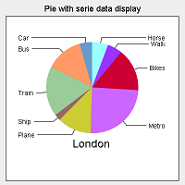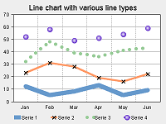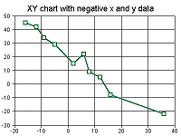

Date | How do humans affect plant and animals around a water source?
Lesson 4  (Multiple day – depends on computer availability) | Objectives:  How can I display my information to an audience?  How do you write a newspaper? | ECC:  Skills and Processes  -1.B.1.a, d  -1.C.1.a, b,  Technology  -ITEA STL 9  ELA  -4.A.1.b  -4.A.1.a,c,f  -2.1.a, c | HOQ:
Resources/Materials | Computers  Jump drives  All related materials to the assignment  Publisher/Word Newspaper template available for student use/viewing
Student Examples | Newspaper template
Warm-Up | Gather all your evidence and data collected through the assignments  Pictures and jump drives included  Sit with your group members and have your computers
Activities/Lesson | - Show the students the newspaper template  - Have the template loaded in a network location or web location  - Students will write their articles and compile into a newspaper. They will need to look at various newspapers to know what is generally printed. From there they will need to adapt their group newspaper to look as realistic as possible, yet include the required writings.  - Required articles  - Obituaries  - Comic Page  - Lead story – Stream health  - Opinion - Witness tree findings  - Compare and contrast of cost of living  - Any other article they deem important for their newspaper
Assessment | Completed newspaper
Homework | Writing articles as needed on own time to keep up with class timeline

Date | How do humans affect plant and animals around a water source?
Lesson 5  (Multiple days – as needed) | Objectives:  How can I track locations on Google Earth?  What is the real world application of uploading points and pictures onto Google Earth? | ECC:  Science  -6.6.A.1.c  -6.6.B.1.c  Technology  -ITEA STL 10 | HOQ:
Resources/Materials | Computers  Google Earth access and prior knowledge of using Google Earth  Pictures from field trip  Waypoints from GPS units from field trip
Examples | Antietam Battlefield Tour (kmz)
Warm-Up | Get your computer and login  Start Google Earth
Activities/Lesson | - Refer the students back to the previous lesson where they learned how to upload points and pictures  - Students will create a virtual field based on their pictures and points from the Antietam Battlefield  - Students need to create the field trip so it can be accessed the next year  - The next year the idea is the students will revisit the GPS waypoint and take pictures to compare and contrast the changes at the location.  - Save trip to your flash drive for future trips
Assessment | Competition of Virtual Field Trip
Homework | Take your parents on your field trip – from your flash drive

END OF FALL PORTION

Date | How do humans affect plant and animals around a water source?
Lesson 6 | Objectives:  What is a watershed?  What watershed do I live in? | ECC:  Science  -7.6.A.1.a  -7.6.B.1.a,b  Technology  -ITEA STL 5  -ITEA STL 3 | HOQ:
Resources/Materials | Computers/internet  Lined paper/pencils  Enrichment – publisher/word/glogster/prezi
Warm-Up | Why is it important to be aware of runoff areas?
Activities/Lesson | - Do not discuss the warm-up question. Just start the exploration.  - Students will visit the website(s) to answer the following questions:  http://water.epa.gov/type/watersheds/whatis.cfm http://www.fergusonfoundation.org/hbf/kidszone_index.shtml  - What is a watershed?  - What watershed do you live in?  - What’s the larger watershed your small watershed flows into?  - What’s a macro invertebrate?  - When the students answer the 3 questions they will bring their answers to the teacher to be approved.  - Students submit their answers under the assignment in Edmodo  - Once the students have approval, they will play “Ways of a watershed” game on the www.fergusonfoundation.org site  - At end of class, revisit the warm-up question as wrap-up/conclusion to the class.  Enrichment: If possible allow the students to create a handout/publication telling others what a watershed is. Be sure to include pictures/diagrams to SHOW what one is as well as explanations.
Assessment | Answering of 4 questions – approval from teacher  Enrichment – Completion of publication documenting the
Homework | None

Date | How do humans affect plant and animals around a water source?
Lesson 7 | Objectives:  Field Study to collect points and identify macro invertebrates at Bush Creek | ECC:  Skills and Processes for all curriculums | HOQ:
Resources/Materials | Rubber boots/waterproof shoes  Dry change of clothes/layers  Lunch  All study materials are provided by BTW/AFF
Warm-Up | None
Activities/Lesson | - Field Trip to stream location (Bush Creek)  - Students will participate in a macro invertebrates study at Bush Creek.  - This trip is ran by The Alice Ferguson Foundation/Bridging the Watershed Program (AFF/BTW)  - Dates are limited but available  - Bus transportation can be reimbursed  - The presenters explain the different equipment to the students as a group  - The students are supervised at the water site but is a requirement to get in the water and search.  - Students will need to keep track of the number, type, and kind of all organisms located  - Students will mark on their GPS units the location of organism collection  - After the students conduct the study they will break for lunch  - The second half of the day is spent touring the battlefield and learning how important the creek was to the battle  - Students should take pictures as they go through the tour/stop
Assessment | Evaluation of day/program  Collection of needed materials/data
Homework | None

Date | How do humans affect plant and animals around a water source?
Lesson 8 | Objectives:  Uploading points to Google Earth  Creating a virtual tour in Google Earth | ECC:  Skills and Processes  -1.B.1.d  -1.C.1.a,b,d,e  Technology  -ITEA STL 3 | HOQ:
Resources/Materials | Field Trip data collection
Warm-Up | Get your computers and login. Load Google Earth.  Gather all materials from yesterday’s field trip.
Activities/Lesson | - Students will take their materials from the previous days trip  - Using their knowledge from the fall, they will recreate a virtual tour  - Students will do extra research about different locations and upload other photos  - Students will create a webquest paper for others to fill in and learn new information that was not gathered at the actual field trip  - Once the trips and quests are complete the students will take turns visiting others field trips to learn new information about the battle or location(s)
Assessment | 3 new facts they learned from other virtual trips
Homework | None

Date | How do humans affect plant and animals around a water source?
Lesson 9 | Objectives:  Identify similarities and differences between different water locations and stream health | ECC:  Science  - 7.6.A.1.a  -7.6.B.1.a,b  Technology  -ITEA STL 3 | HOQ:
Resources/Materials | Fall Virtual Trip and Spring Virtual Trip on Google Earth  Computers  Jump drives
Warm-Up | What were the similarities/differences between the fall and spring field trips?
Activities/Lesson | - Create a class T-Chart showing the similarities and differences between the two locations/experiences  - Lead the students into determining the similarities and differences among the land structure/layout.  - Have the students use Google Earth to research the reasons/evidence for the similarities or differences.  - The students will present an electronic report on their findings of stream health and reasons for such.  - Other information the students need to include:  - Population densities of the area  - What happened in the past to cause the future? (what impact have humans had due to development, on your stream findings)  - What has changed in your locations? Major buildings? (include time/year)  - Any signification information  Enrichment – create a movie of your findings, with Movie Maker, instead of just a poster or electronic 2D presentation.
Assessment | 3 new facts they learned from other virtual trips  Electronic presentation of findings
Homework | None

Date | How do humans affect plant and animals around a water source?
Lesson 10 | Objectives:  Continue fall and spring fieldtrip comparison/contrast evaluation | ECC:  Science  - 7.6.A.1.a  -7.6.B.1.a,b  Technology  -ITEA STL 3 | HOQ:
Resources/Materials | Fall Virtual Trip and Spring Virtual Trip on Google Earth  Computers  Jump drives  Google Earth  Internet resources  Excel/graph maker  Prezi
Warm-Up | What were the similarities/differences between the fall and spring field trips?
Activities/Lesson | - Students will take the information from previous trips and research to locate a new water source to look at.  - The students will find the water source on Google Earth and utilize the internet to find the different water indicators of stream health.  - Students will need to contact land and resource departments to get information  - Determine water source name  - Watershed name  - Pulling together all information learned in previous lessons  - Students need to analyze the surrounding areas to determine what is causing or helping the stream health  - Create a data chart to display collected information  - Display data, if possible in graphs  - Students need to present all findings/analysis in Prezi
Assessment | Analysis of a new location’s stream health
Homework | None

Websites for PBL
http://www.fmr.org/projects/shep
http://www.usgennet.org/usa/ny/county/ontario/military/civilwarobits.htm
http://www.foodtimeline.org/foodpioneer.html#provisionprices
http://www.suite101.com/content/life-as-a-civil-war-soldier-a83509
http://www.google.com/search?hl=en&safe=active&rlz=1R2ADRA_enUS430&biw=1259&bih=583&tbm=isch&sa=1&q=tombstone+civil+war&oq=tombstone+civil+war&aq=f&aqi=&aql=&gs_sm=e&gs_upl=12188l13719l0l13844l10l10l0l7l7l0l172l375l1.2l3l0&surl=1
http://www.brotherswar.com/Antietam-1.htm
http://www.swiftchart.com/example.htm

