STEM Light Challenge
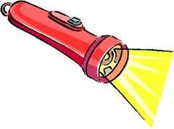

Submitted by:

Fountaindale School for the
Arts and Academic Excellence

Grade 5

STEM Elementary Mini Lesson Template

STEM lessons will take a transdisciplinary approach. This template is designed to aid in the development of a transdisciplinary STEM lesson.

Title: STEM Light Challenge

Grade Level: Fifth Grade

Questions to ask before designing a lesson:

- What is the essential question(s) for the lesson?

How does light travel from one place (source) to another?

  - Why is this question relevant?
This question is relevant because it is the practical application of the standard.

  - What is the connection to real life?
Students will use light in order to communicate with one another.

- What techniques are used to make the lesson inquiry based?

The whole lesson is inquiry based. The students were presented with a problem and then had to solve this problem through trial and error, which is the engineering model.

- What are the lesson outcomes?
See the attached rubric for student assessment.

- How is participant discourse promoted?
Students were required to not only present their work to the group, but they were also required to generate a more probing discussion and critique one another’s work through these discussions. They were also required to wrap up their conclusions with a critique in writing.

- How are science, technology, engineering, and mathematics addressed in the lesson?
See the attached curricular connections.

Lesson Title: STEM Light Challenge
Curricular Connection   | Science:  1.0. Skills and Processes (Imbedded)  5.D.3 Provide evidence to show that light travels in a straight line until it is reflected or refracted.  5.D.3.a. Observe and describe the images formed by a plane mirror.  *Size of the image  *Apparent distance of the image from the mirror.  *Front to back reversal of the image.  5.D.3.b Based on observations trace the path of a ray of light before and after it is reflected off a plane mirror.  5.D.4.a Classify materials as transparent, translucent, or opaque.  Math:  3.B.1.a Select and use appropriate tools and units.  3.B.2.a Measure a single angle and angles in regular polygons.  Writing:  CCW1: Write opinion pieces on topics or texts, supporting a point of view with reasons and information.  CCW2.d Use precise language and domain-specific vocabulary to inform about or explain the topic.  CCSL4: Report on a topic or text or present an opinion, sequencing ideas logically and using appropriate facts and relevant, descriptive details to support main ideas or themes; speak clearly at an understandable pace.
Materials/  Resources   | Teacher Materials |  | Student Materials
 | Computer and Document Camera (for ease of unpacking the activities/challenges) |  | From the FOSS Matter and Energy Kit:  - Flashlights  - Mirrors and clips  - Matter and Energy Science Resource  Other Materials Needed:  - Laser pointers  - Computers with the internet access  - Yarn  - Protractors  - Ruler/Yardsticks/Measuring tape  - Other approved materials as needed
Safety  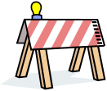 | Remind students that they should not look directly into light sources such as laser pointers, flashlights, or the sun. Looking directly into these light sources can cause damage to the eyes.
Focus Question   | How does light travel from one place (source) to another?
Vocabulary   | light ~ flash, glare, colored sparkle, bright twinkle, and soft glow that fills our space
 | light source ~ sources that produce light (sun, flashlight, flames, etc.)
 | reflect ~ to bounce off an object or surface
 | image ~ two-dimensional picture, that has a similar appearance to some subject
 | plane mirror ~ a shiny surfaces that reflects light
 | distance ~ is a numerical description of how far apart objects are
 | angle ~ two rays that share an endpoint
5 E Model | Time Frame | Activity
Engage    &  Explore   | Science- 1 Class Period  and/or  ELA Class Period | Day 1 Gaining Background Information About Light: Use FOSS Matter and Energy Investigation 2, Matter and Energy Science Resource, internet research.  Task (see page 6 in this packet): Using 21st Century Skills (Specifically the 4 Cs), create a method for our classes to communicate with each other using light. See page 8 in this packet for a sample poster of the 4Cs. A rubric for this task is on page 7 of this packet.  Read the passage about Morse Code and discuss how light can be used for communication. Summarize and infer about the process used to make this happen for the students to complete the task. (Refer to YouTube video http://www.youtube.com/watch?v=JGpKlMz1lFg)
Explore | 3-4 hours, Preferably in 1 or 2 days span. | Days 2-3 The students will use this time to work through the engineering design process (see page 9 in this packet for guidance). The students will be provided the materials for exploring possible solutions.  Students will then have an extended class period to be sure their plan is written accurately so it can be followed or reproduced by others.
Explain   | 15 minutes per group presentation X the # of student groups. | Days 4-5 Students will be required to present their ideas to the class/classes involved. They will be required to explain their plan, steps, processes, information they learned while working, any challenges or obstacles they overcame, and/or anything else they feel would explain their work to the group.  The audience members (students) will be required, as part of their presentation grade, to ask probing questions of the group presenting, in order to further understand their processes and to push the thinking of the engineering and scientific processes. Students will have 5 minutes to set up and 10 minutes for presenting and questions from the audience.
Evaluate   | During presentations on Days 4-5 (number of days depends on number of presenting groups and allotted class period) | - Students will critique each other’s presentations by asking clarifying and probing questions of each group. They will be held accountable for these questions through the rubric component, which requires their score to be dependent upon each member of the group asking these critiquing questions.  - After the presentations are completed, students will vote for the plan they felt was the best with the rubric in consideration. Students will then write to defend their thinking by explaining why this plan was the best one. Plans chosen will be copied for the students to use as a text for providing evidence in their writing. Their evidence should include which components of the written plan qualify this plan as exceptional.
Extension Ideas  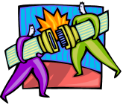 |  | - Learn more about Morse code and create a message that could be transmitted.  - Learn about the use of lighthouses as signal beacons.  - Learn about some of the other uses for lasers.

STEM Challenge 1

Essential Question: How can students in Ms. Leard’s and Ms. Boschen’s rooms communicate with each other using our knowledge of light?

Vital Information: How does light travel from one place (source) to another?

The materials that can be used are:
Laser Pointers
Flashlights
Mirrors
FOSS Matter and Energy Science Resource
Protractors
Ruler/yardsticks/ measuring tape

Task: Using your 21st Century Skills (Specifically your 4 Cs) create a method for our class to communicate with Mrs. Boschen’s class using light.
- You will have one day to create your plan for how you will accomplish the task.
- You will then have an extended class period to be sure your plan is written in a thorough way, in which others could follow or reproduce your plan.
- Your plan should have content specific vocabulary, outlining how to accomplish your plan. Words like angles, the types of angles, and measurements (Linear in inches to the 1/8 of an inch) will be required. If you use specific angle measurements in degrees you will be going beyond the set standard.
- Be ready to present your plans to the entire 5th grade class by ___________________________________________.
- After all groups have presented, you will vote on which plan we find most effective in each class. Then you will write an argumentative proposal for which plan is most effective and convincing!
- Our class will use this plan from time to time throughout the school year!

STEM Challenge Rubric

Science (2 x 5 points each = 10 total points)
____ Your plan accurately explains how light
travels from one place to another.
____ Your plan accurately gets communication
from one room into the other.

Math (3 x 5 point = 15 points total)

____ Your plan has content specific vocabulary for measurement and geometry.
____ You incorporate the types of angles in your plan explanation so that
your plan can be easily followed or duplicated. (Specific angles measures show the students have exceeded the standard.)
____ You incorporate precise linear measurement, in inches to the 1/8 of an
inch, so that your plan can be easily followed or duplicated.

Presentation and Audience (2 x 5 point = 10 points total)

____ Your group clearly presented your plan to both classes.

____ Your group members furthered the thinking of at least one other group by asking at least one critiquing question of a group’s plan.

Self-Score ________ / 35 points

Teacher Score ________ / 35 points

4 Cs Sample Poster

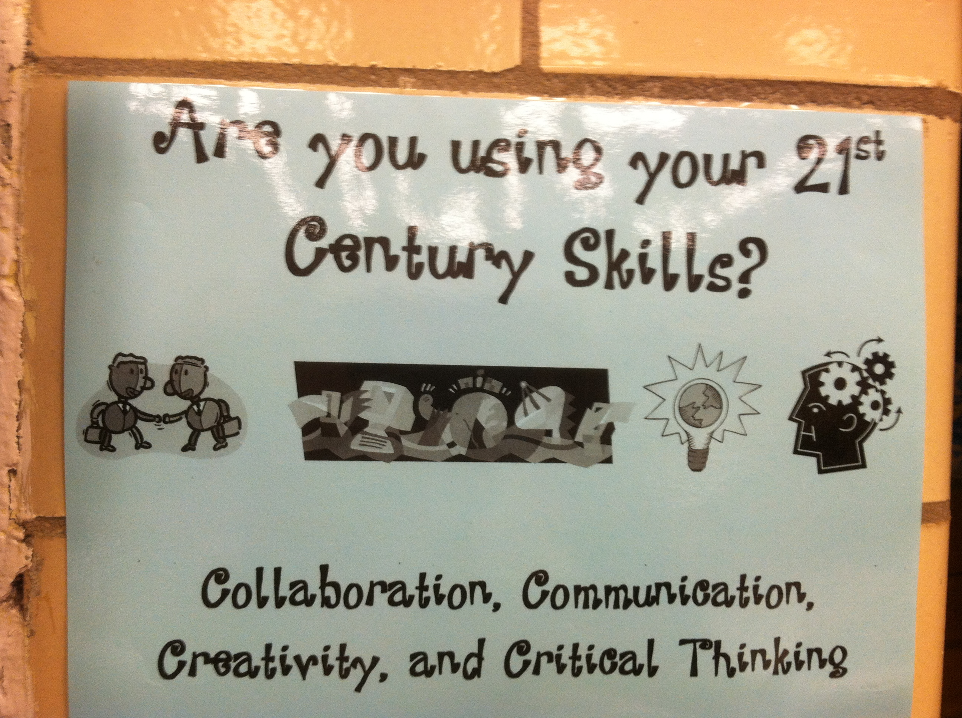

Engineering Design Process

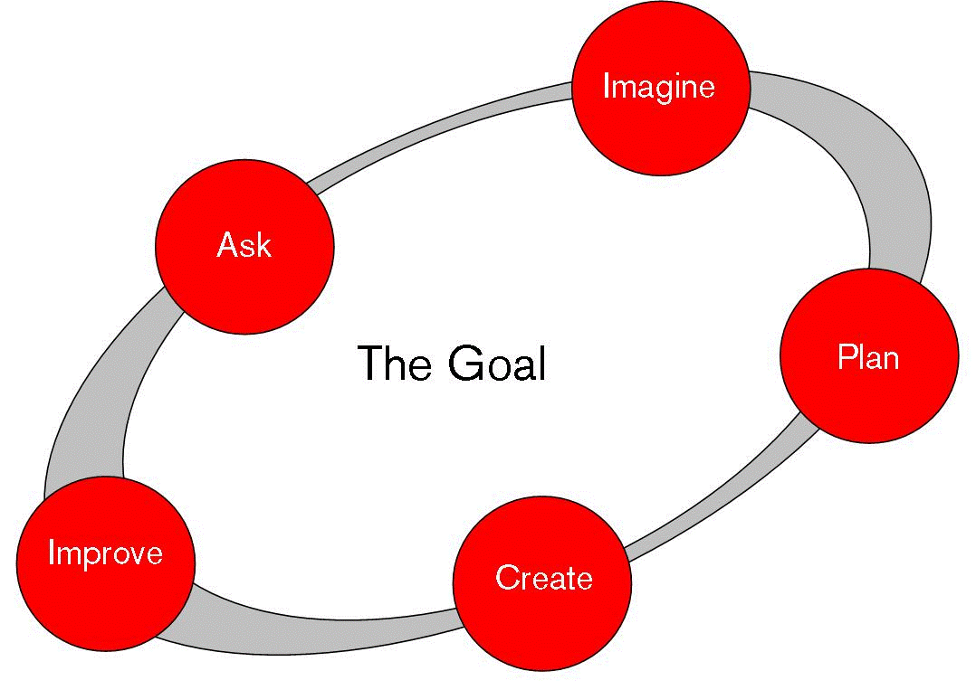

Resource: Engineering is Elementary: http://www.mos.org/eie/engineering_design.php

