**Grade 5**

**Unit Title: Mass Confusion**

**Length of Unit: Ongoing throughout**

|  |  |
| --- | --- |
| Stage 1 | Unit Standards: |
| **Science**  **5.4.B.1** Cite evidence to support the statement that, "No matter how many parts of an object are assembled, the [mass](javascript:openPopupWH('/share/vsc/glossary/science/mass.html',200,200)) of the whole object made is always the same as the sum of the parts."  **Math**  **4MD4 Mass of Objects**  **4MD5 Degrees**  **4MD6 Measuring Angles**  **4G1 Lines and Figures**  **5MD1 Volume**  **5MD2 Volume**  **5MD3 Volume**  **5MD4 Volume**  **5MD5 Volume**  **5MBT7 Costs, whole number computation**  **ELA**  **Speaking and Listening**  **SL5.4**  **SL3.5**  **Reading**  **RI5.1**  **RI5.10**  **Writing**  **W.5.1**  **W.5.7**  **W.5.9**  **Social Studies** |
| Established Goals (from the standards) |
| **Science**   * Use evidence to describe how matter can change from one form to another without the loss of any mass. (5.4.B.1.b) * Describe the relationship between the masses of whole objects to the sum of the mass of their parts. (5.4.B.1.c) |
| Enduring Understandings(general): |
| * Conservation of mass. |
| Big Ideas (content specific): |
| **Science**   * Mass is neither created nor destroyed, but is conserved. |
| Essential Question (s): |
| * What is the relationship between the masses of whole objects to the sum of the mass of their parts? |
| Stage 2 | Student Outcomes: (Unit) |
| The students will know…  **Science**   * How matter can change from one form to another without the loss of mass. * The relationship between masses of whole objects and mass of sum of their parts.   The students will be able to…  **Science**   * Explain how matter can change from one form to another without the loss of mass. * Describe the relationship between masses of whole objects and the mass of the sum of their parts. |
| Summative Assessment: (end of the Unit) |
| * Evaluation of hypothesis * Peer Procedure Evaluation * End of testing report |
| Stage 3 | Anticipated areas of Concern: (1A Prerequisites and misconceptions) |
| * Belief that changing the shape of an object or multiple objects will change the mass of said objects. * Understanding the difference between weight and mass. |
| Learning Experience(s) and Resources: (to support important pre-requisites, content, and/or assessment) |
| **Science** |
| Continuous Assessment: |
| Rubrics and Checklists to assess process and content:   * BIE Critical Thinking Rubric * BIE Teamwork Rubric * Formative science assessments and checklists in WCPS Unit Guide and FOSS Manual * ELA Common Core SL1a |
| Challenges (as assessment; possibly to support Learning Experiences) |
|  |
| **Engineering Design Process and Instructional Setting** |
| The instructional setting is designed to model the Engineering Design Process. However, the students will experience the Engineering Design Process in a fluid manner. Examples provided are suggested resources/tools that the teacher **may** **consider** to use. Each unit is just one part of an overarching unit. For example, the entire Mixtures & Solutions unit is not addressed in this document, rather a set of lessons to teach one part of the unit, utilizing your LEGO Robotics kits. |
| **Define Problem or Goal UNIT 1 (Mixtures & Solutions)** |
| **Classroom Teacher and Coach**:   * Presents challenge provided as design brief. * Provides an opportunity for student questions regarding the challenge. (Example: Prompt: What do I need to know and do to complete this challenge?, KWS Chart, Project Team Work Plan)   **Student:** (Whole group and small group)   * Develops inquiry questions regarding the challenge. (Examples: How do we measure the mass of the whole compared to the mass of the parts? How can we appropriately organize our data to present it to the other members of the classroom team?) * (Optional) After students have seen the design challenge and formulated inquiry questions, choose specific jobs that must be done in each group. Jobs could include, but are not limited to; designers, marketing and research, managers, builders, etc. Make a chart for each job and have students do a gallery walk to add possible responsibilities for each job. Hang each poster and have students “apply” for a job based on their skill sets. Students can then be “hired” for certain jobs in each group, or hire managers first, then allow them to “hire” other students for the remaining jobs on their teams. (This process could be repeated throughout the year to allow students opportunities to prove their skill sets, and build their “resumes” for future job assignments.)   **Time frame:** 1 class period |
| **Brainstorm and Research** |
| **Classroom Teacher**:   * Provides investigations/instruction to develop understanding of science and math content. (**Example: Investigation on difference between weight and mass. Investigation on how to use a triple beam balance**. **Investigation on how to write hypothesis, scientific procedures.**) * Provides various resources for students to research. (**Example**: ) * Provides opportunities for students to explore robotic materials. (Example: LEGO Robotics Lessons or free exploration during indoor recess)   **Student:** (Whole group, Pairs, and Individual)   * Investigates inquiry questions during science and math investigations/instruction. * Researches inquiry questions with both print and digital resources. * Records findings. (Example: Information, Source, Page Organizer, Blog Postings or in Science Notebook)   **Time Frame:** Several opportunities over time. |
| **Develop Ideas** |
| **Classroom Teacher and Coach**:   * Provides a process for students to work as a team while exploring options for completing the challenge. (Example: Balloon Action Planning, BIE Creativity and Innovation Rubric, BIE Project Team Contract)   **Student:** (Small Groups)   * Uses information from investigations and research to apply their knowledge to explore options for completing the challenge. * Creates a testable hypothesis for what they believe will happen in their investigation based on what they have learned from their investigations and research.   **Time Frame:** 1 class period |
| **Choose an Idea** |
| **Classroom Teacher:**   * Provides a process for creating procedures for testing their hypothesis.   **Student:** (Pairs)   * Applies what they have learned from investigations and research to create a set of repeatable procedures.   **Time Frame:** 1 class period |
| **Test and Evaluate** |
| **Classroom Teacher:**   * Provides time for students to build and test their models, following their procedures. * As groups finish have them create additional tests to confirm their results. * Once all groups have run their tests announce that the company would like to evaluate each team’s procedures. Have groups switch procedures with another group (for example: groups with strong procedures switch with groups with weak procedures based on your observations)   **Student:** (Small Groups)   * Follows procedures to test their hypothesis. * Makes amendments to procedures where necessary. * Conducts additional tests to confirm results. * Records data from each test (Data Collection Sheet, Science Notebook) * After switching procedures have groups follow those procedures to test their hypothesis, making notes for recommended changes to procedures as needed.   **Time Frame**: 1-2 class periods |
| **Communicate** |
| **Classroom Teacher:**   * Provides time for the students to showcase their procedures and findings. (Example: BIE Presentation Rubric for formal presentation ~ Common Core ELA SL4 and SL5)   **Student:** (Small Groups to Whole Group)   * Present their procedures and findings (PowerPoint, etc.)   **Time Frame**: 1-2 class periods |
| **Conclude** |
| **Classroom Teacher:**   * Provides a process for students to communicate what they learned. (Blog, Science notebook, etc.)   **Student:** (Work on their own)   * Process what they have learned.   **Time Frame:** 1 class period |

**Design Brief for Mass Confusion**

**Grade 5**

C:\Users\kopcochr\AppData\Local\Microsoft\Windows\Temporary Internet Files\Content.IE5\AQPZGMYJ\MC900078811[1].wmf

**Background**

You have just been hired in the shipping department for a brand new toy robot manufacturing company called _________. Your boss has just come to you and your team with a dilemma that, if solved, will ensure your rapid promotion from Shipping to Building and Design, where you know you truly belong. The president of your company has stated that your shipping costs are unnecessarily high and that you could cut down on costs just by changing how the parts of the robot are arranged in their packaging. The president also stated that this must be done with the same packaging that is currently used since the company has a whole warehouse full of these boxes that must be used. Your boss believes that rearranging the parts of the robot in the same packaging will not cut down on shipping costs, but needs proof to convince the president of the company.

**Design Challenge**

Your mission is to determine whether the cost of shipping a robot is affected by the way in which the parts of the robots are arranged in a container. To complete this challenge you must create a set of repeatable procedures that you will then use to test whether rearranging the parts of the robot in the same container will change the cost of shipping the robot. Your data and conclusion must then be formally presented to your boss in a way that can be presented to the president of the company at a later date.

**Criteria & Constraints**

* + The robots are currently shipped pre-assembled.
  + Robots will be shipped in the same container with no packaging materials regardless of how the pieces are rearranged.
  + You must come up with a set of testable procedures which can be repeated if necessary.
  + You must collect your data with available materials.
  + You must clearly show how your data supports your conclusion.

|  |  |
| --- | --- |
| **Materials** | **Tools** |
| * LEGO Robotics Kit * Project folder | * Paper and Pencil * Triple Beam Balance |

**Resources**

The following pages include the examples mentioned in the instructional setting descriptions.

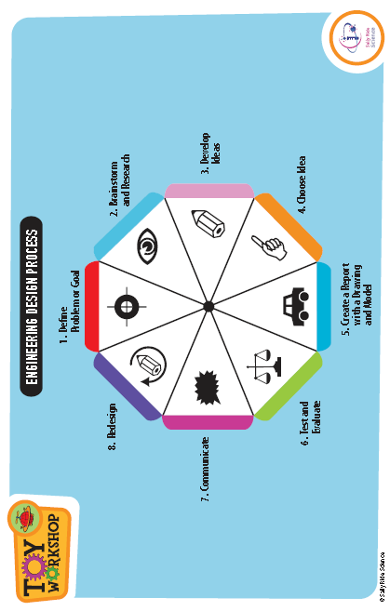

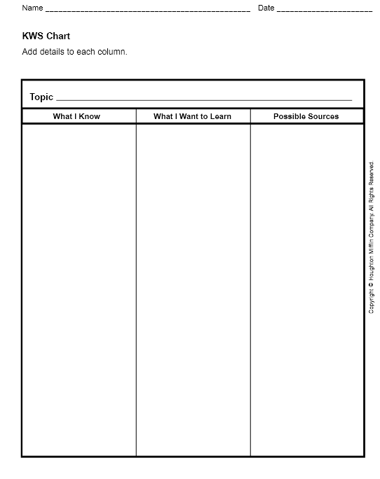

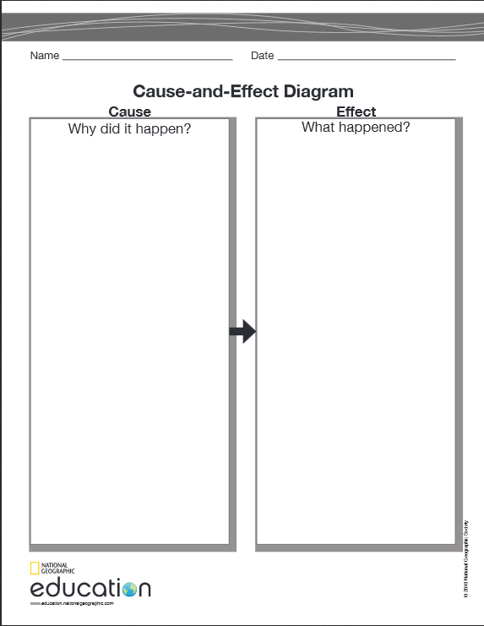

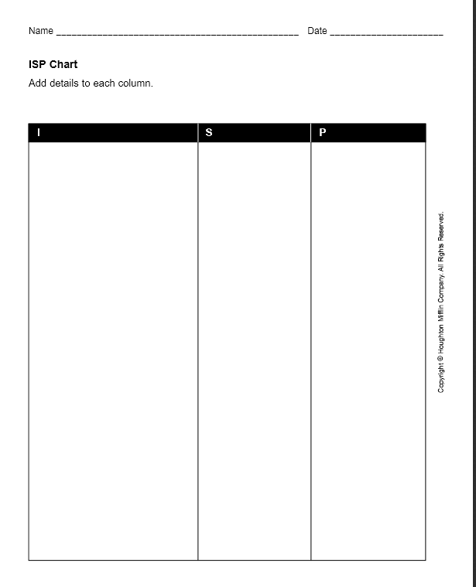

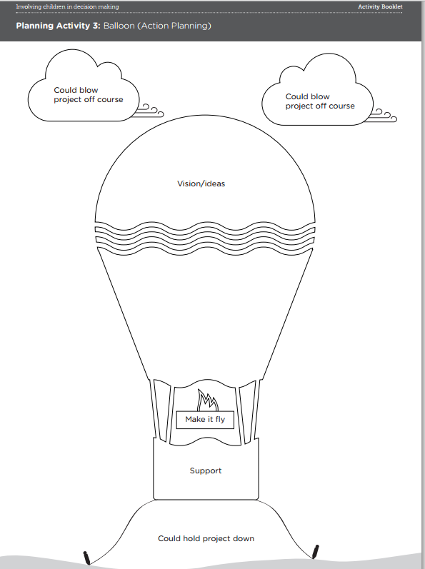

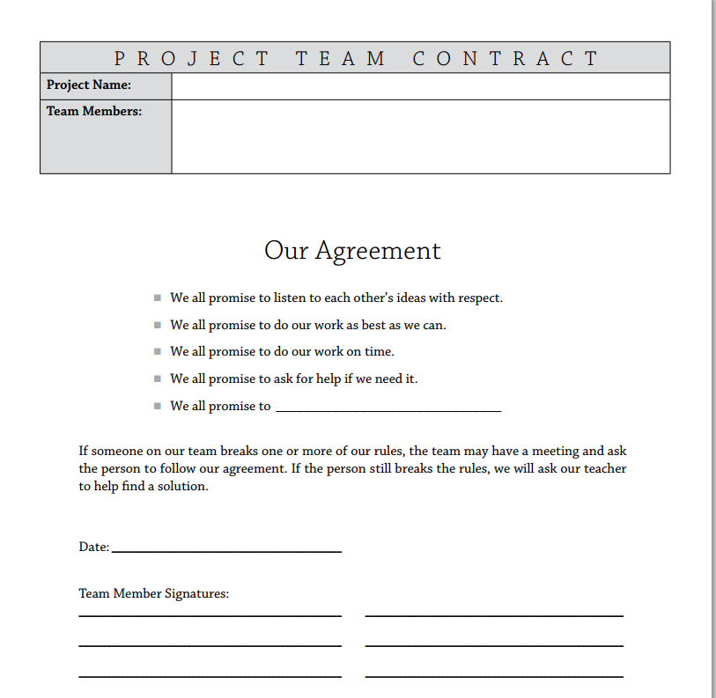

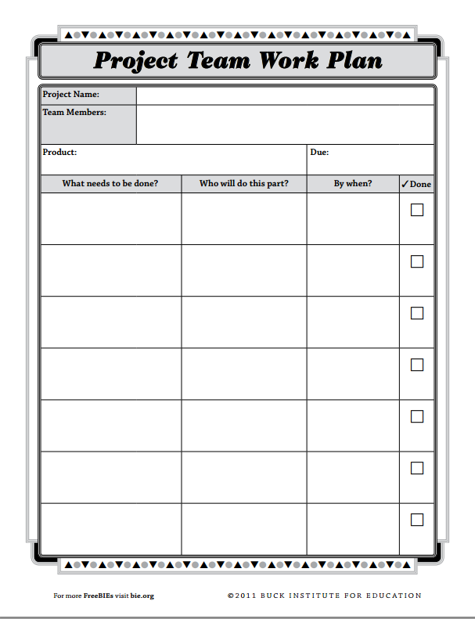

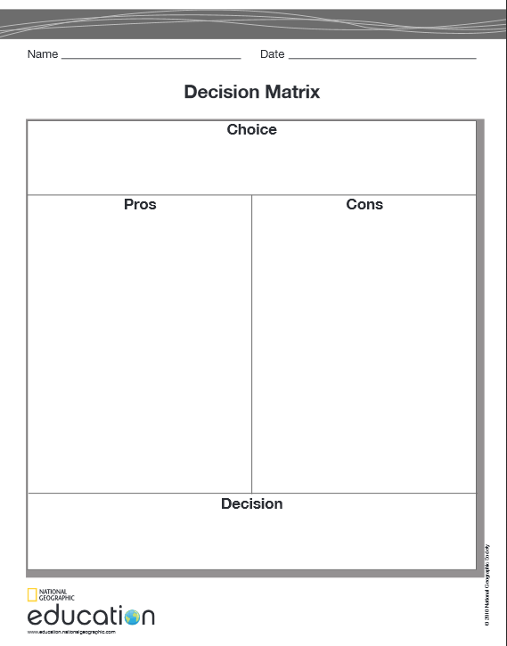

Name ______________________________________________

**Test and Evaluate Graphic Organizer**



