Grade 2
Unit Title: Robotics to the Rescue
Length of Unit: 2-3 weeks

Stage 1 | Unit Standards:
Science
K.5.A.1 Compare the different ways object move.
K.5.A.2 Explain that there must be a cause for changes in motion of an object.
3.5.A.1 Cite evidence from observations to describe the motion of an object using position and speed.
K.5.A.2 Explain there must be cause for change in motion of objects.
2.4.A.1 Cite evidence that most things are made of parts.

Math
2.MD.1 Measure the length of an object by selecting and using appropriate tools such as rulers, yardsticks, meter sticks, and measuring tapes.
MP5 Use appropriate tools.
MP6 Attend to precision.

ELA
RI9 Compare and contrast the most important points presented by two texts on the same topic.
 | Established Goals: (from the standards)
Science
- Take objects apart and rearrange the parts to identify and describe how the parts work together. (1.4.A.1.b)
- Describe and compare how objects move. (K.5.A.1.a)
- Describe how motion can be changed. (K.5.A.2.a, 3.5.A.2.a)
- Ask and seek answers to “What if” questions about the changes made to the objects and how they affect the way objects work, for example, if a part were left out of the object would it make a difference in how the object works. (2.4.A.1.c)
 | Enduring Understandings(general):
- Patterns in the natural and human designed world can be observed and used as evidence. Patterns of change can be used to make predictions.
- Systems in the natural and designed world have parts that work together.
- Cause and effect relationships are routinely identified.
 | Big Ideas (content specific):
Science
- Scientific discoveries about the natural world can often lead to new and improved technologies, which are developed through the engineering design process.
- The patterns of an objects motion in various situations can be observed and measured; when past motion exhibits a regular pattern, future motion can be predicted from it (size and direction).
 | Essential Question (s):
 | How are ideas from math and science used to develop and improve technologies?
Stage 2 | Student Outcomes:
The students will know…
Science
- a change in parts of a system may cause a change in motion.
- patterns help make predictions.

The students will be able to…
Science
- describe motion of an object.
- identify the cause of change in the motion of an object.
- build and program the robot to demonstrate change in motion on a straight path.
 | Summative Assessment: (end of the Unit)
Rubric developed from criteria included in design brief…
- Your robot must demonstrate moving along the designated path.
- The path must be precisely measured with the appropriate tools.
  - Total length of the path must be 175 centimeter long.
- Your robot must stop at designed areas along the path.
  - Stop 1: 80 centimeters
  - Stop 2: 140 centimeters
  - Stop 3: 170 centimeters
Stage 3 | Anticipated areas of Concern: (1A Prerequisites and misconceptions)
 | Learning Experience(s) and Resources: (to support important pre-requisites, content, and/or assessment)
Science
- FOSS: Balance and Motion, Investigation 2 Parts 1 and 2
- FOSS Science Stories from Balance and Motion, Machines and Tools and Rolling, Rolling, Rolling
 | Continuous Assessment:
Rubrics and Checklists to assess process and content:
- BIE Critical Thinking Rubric
- BIE Teamwork Rubric
- Formative science assessments and checklists in WCPS Unit Guide and FOSS Manual
- ELA Common Core SL1a
 | Challenges (as assessment; possibly to support Learning Experiences)
 | Engineering Design Process and Instructional Setting
 | The instructional setting is designed to model the Engineering Design Process. However, the students will experience the Engineering Design Process in a fluid manner. Examples provided are suggested resources/tools that the teacher may consider to use.
 | Define Problem or Goal
Classroom Teacher and Coach:
- Presents challenge provided as design brief.
- Provides an opportunity for student questions regarding the challenge. (Example: Prompt: What do I need to know and do to complete this challenge?, KWS Chart, Project Team Work Plan)
Student: (Whole group and small group)
- Develops inquiry questions regarding the challenge. (Examples: How do the different parts make the robot move? How do I use measurement to test and demonstrate the motion of the robot?)
Time frame: 1 class period
 | Brainstorm and Research
Classroom Teacher:
- Provides investigations/instruction to develop understanding of science and math content. (Example: FOSS: Balance and Motion Investigation 2 Parts 1 and 2)
- Provides various resources for students to research. (Example: FOSS: Science Stories from Balance and Motion, Machines and Tools and Rolling, Rolling, Rolling during other blocks of time (ELA, Core Extension, and/or Tech Day/Media))
- Provides opportunities for students to explore robotic materials. (Example: LEGO Robotics Lessons or free exploration during indoor recess)
Student: (Whole group, Pairs, and Individual)
- Investigates inquiry questions during science and math investigations/instruction.
- Researches inquiry questions with both print and digital resources.
- Records findings. (Example: Information, Source, Page Organizer or in Science Notebook)
Time Frame: Several opportunities over time.
 | Develop Ideas
Classroom Teacher and Coach:
- Provides a process for students to work as a team while exploring different robotic designs for completing the challenge. (Example: Balloon Action Planning, BIE Creativity and Innovation Rubric, BIE Project Team Contract)
Student: (Pairs)
- Uses information from investigations and research to apply their knowledge to explore possible robotic designs for completing the challenge.
Time Frame: 1-2 class periods
 | Choose an Idea
Classroom Teacher:
- Provides a process for the students to choose one design/idea. (Example: Decision Making Matrix)
Student: (Pairs)
- Applies what they have learned from investigations and research for choosing one design idea.
Time Frame: 1 class period or do at the end of the 2nd class period of Develop Ideas
 | Create a Report with a Drawing and Model
Classroom Teacher and Coach:
- Provides a process for students to work as team for building their robot. (Example: BIE Teamwork Rubric)
Student: (Pairs)
- Builds the robot, photographs the robot, and records important information about the design.
Time Frame: 1 class period
 | Test and Evaluate
Classroom Teacher:
- Provides a process for students to test their model. (Example: World Café Protocol)
- Provides a process for students to receive peer feedback. (Example: Test and Evaluate)
Student: (Pairs meeting with Pairs)
- Tests their robotic design.
- Provides and receives feedback.
Time Frame: 1 class period
 | Communicate
Classroom Teacher:
- Provides time for the students to showcase their robotic design. (Example: BIE Presentation Rubric for formal presentation ~ Common Core ELA SL4 and SL5)
Student: (Pairs present to Whole Group)
- Uses their robot to demonstrate completion of challenge.
Time Frame: 1-2 class periods
 | Redesign
Classroom Teacher:
- Provides time for the students to revise their design.
- Provides time for students to reflect about the challenge. (Examples: BIE My Thoughts About the Project)
Student: (Pairs)
- Uses the materials to revise their design or communicate how they would revise their design.
- Reflects about the challenge.
Time Frame: 1 class period

Design Brief for Robotics to the Rescue
Grade 2
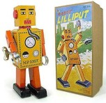
Background
In 1932 the first true robot toy was produced in Japan. The ‘Lilliput’ was a wind-up toy which walked and waved its arms. It was made from tinplate and stood just 15 centimeters tall. Robots have changed dramatically since ‘Lilliput’ and are not just toys. Robots assist humans in variety of ways. How could a robot help you?
Design Challenge
Explorers to the Rescue needs your assistance with building a robot that will explore an area. Design an exploring robot that will move and stop along a designated path. Each team must follow the criteria for this challenge. The Engineering Design Process will help your team focus on this challenge.
Criteria
- Your robot must demonstrate moving along the designated path.
- The path must be precisely measured with the appropriate tools.
  - Total length of the path must be 175 centimeter long.
- Your robot must stop at designed areas along the path.
  - Stop 1: 80 centimeters
  - Stop 2: 140 centimeters
  - Stop 3: 170 centimeters

Materials | Tools
- LEGO Robotics Kit  - Masking tape  - Project folder | - Paper and Pencil  - Measuring tools  - Digital Camera (iPad)

Resources

The following pages include the examples mentioned in the instructional setting descriptions.
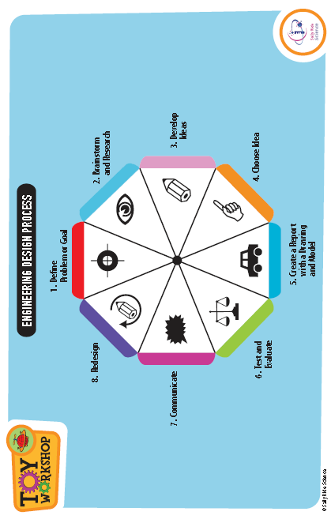
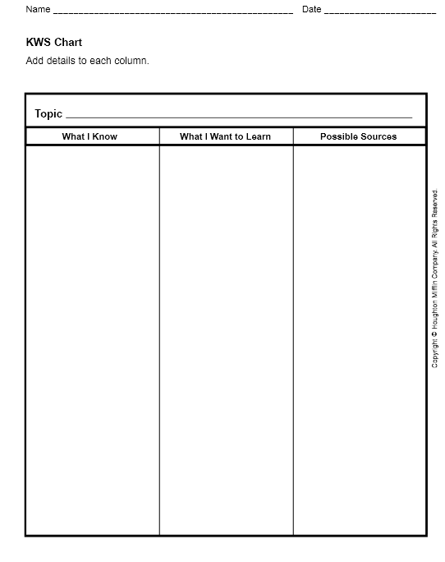
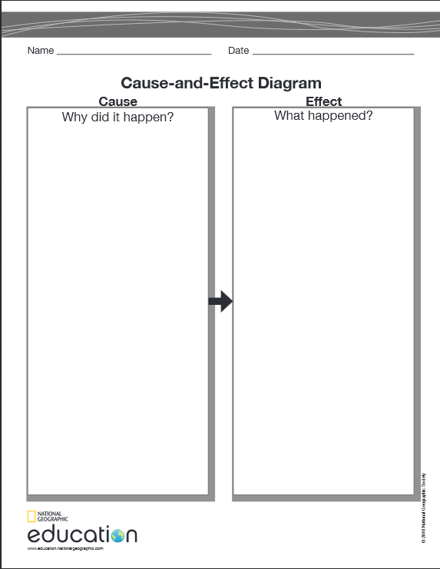
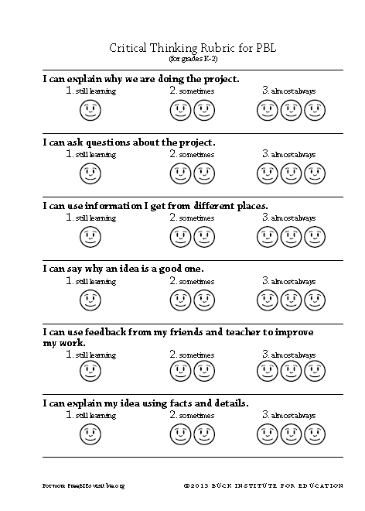
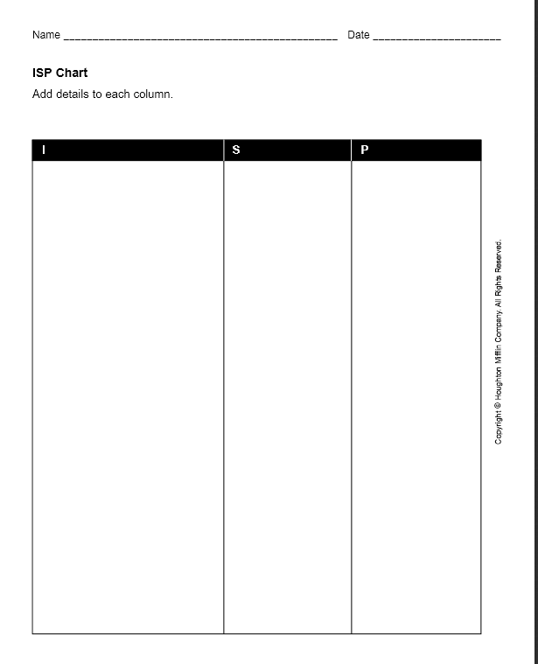
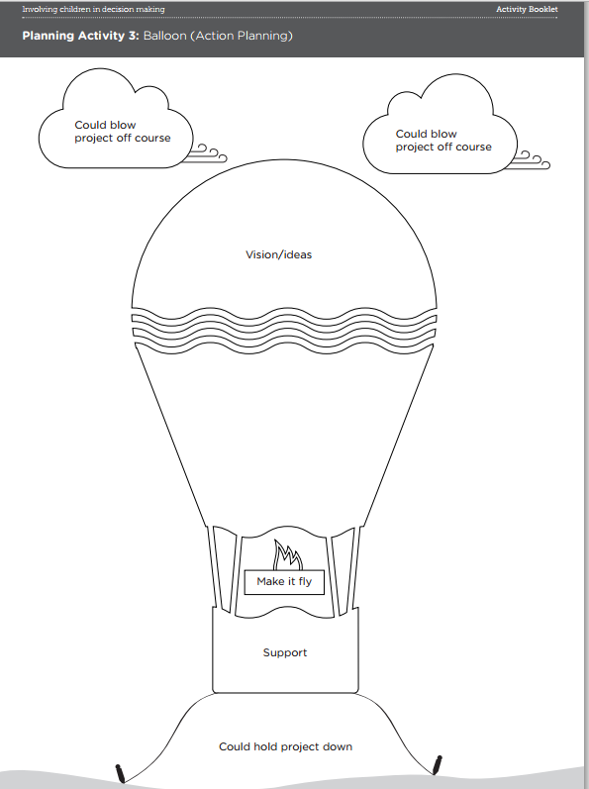
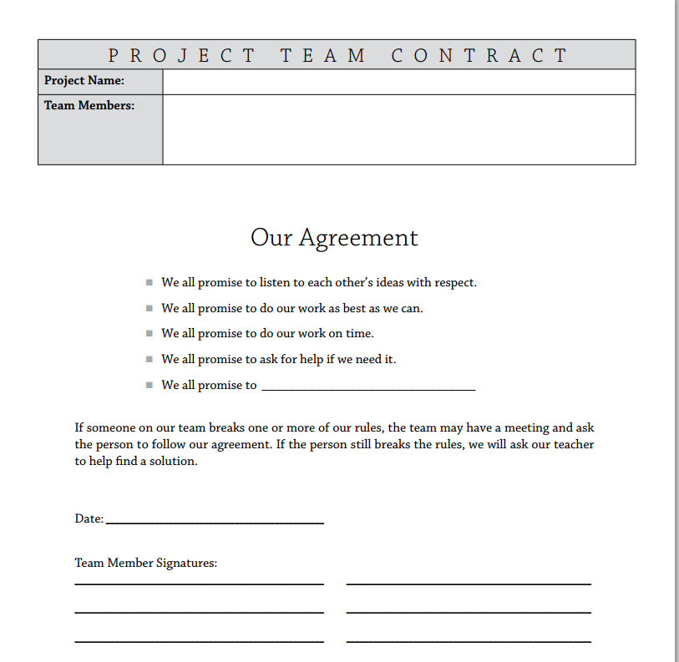
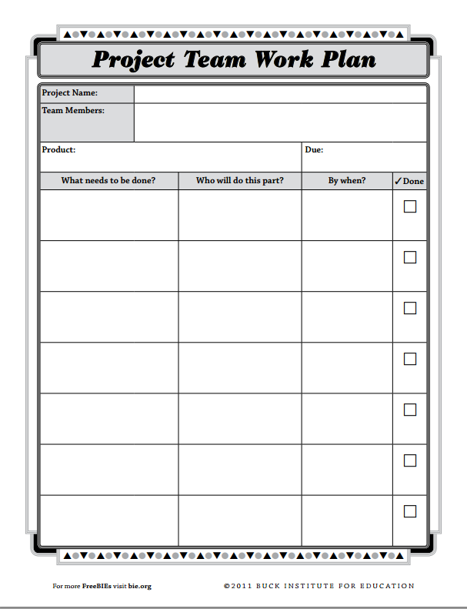
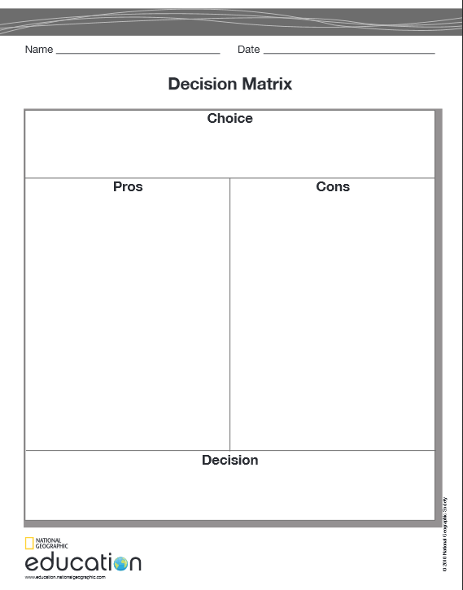
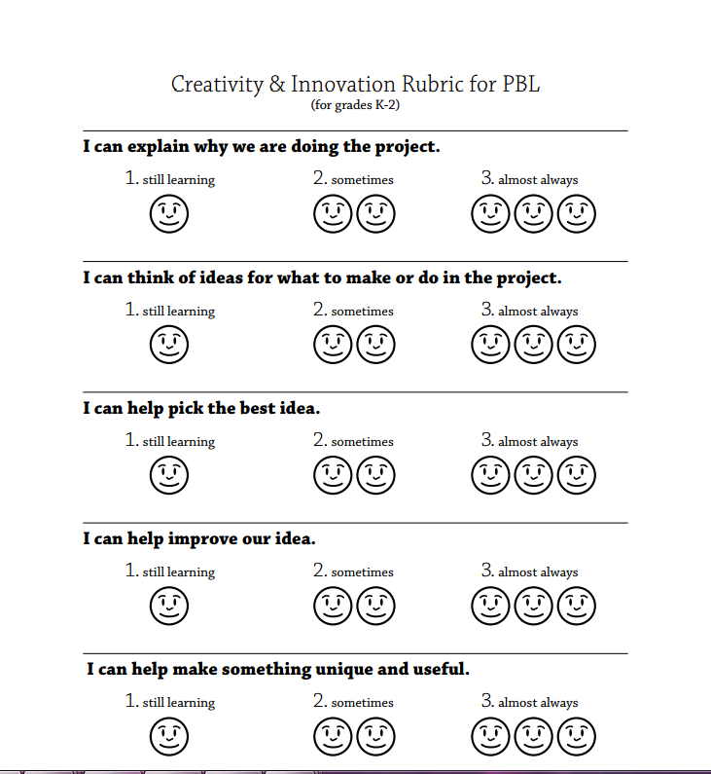

Teamwork Rubric
(for grades K-2)
I do my work for the team on time.
 | 1. still learning | 2. sometimes | 3. almost always
I help my team.
 | 1. still learning | 2. sometimes | 3. almost always
I listen to the ideas of my teammates.
 | 1. still learning | 2. sometimes | 3. almost always
I share my ideas with my team.
 | 1. still learning | 2. sometimes | 3. almost always
I treat my teammates with respect.
 | 1. still learning | 2. sometimes | 3. almost always

Name ______________________________________________

Test and Evaluate Graphic Organizer
